

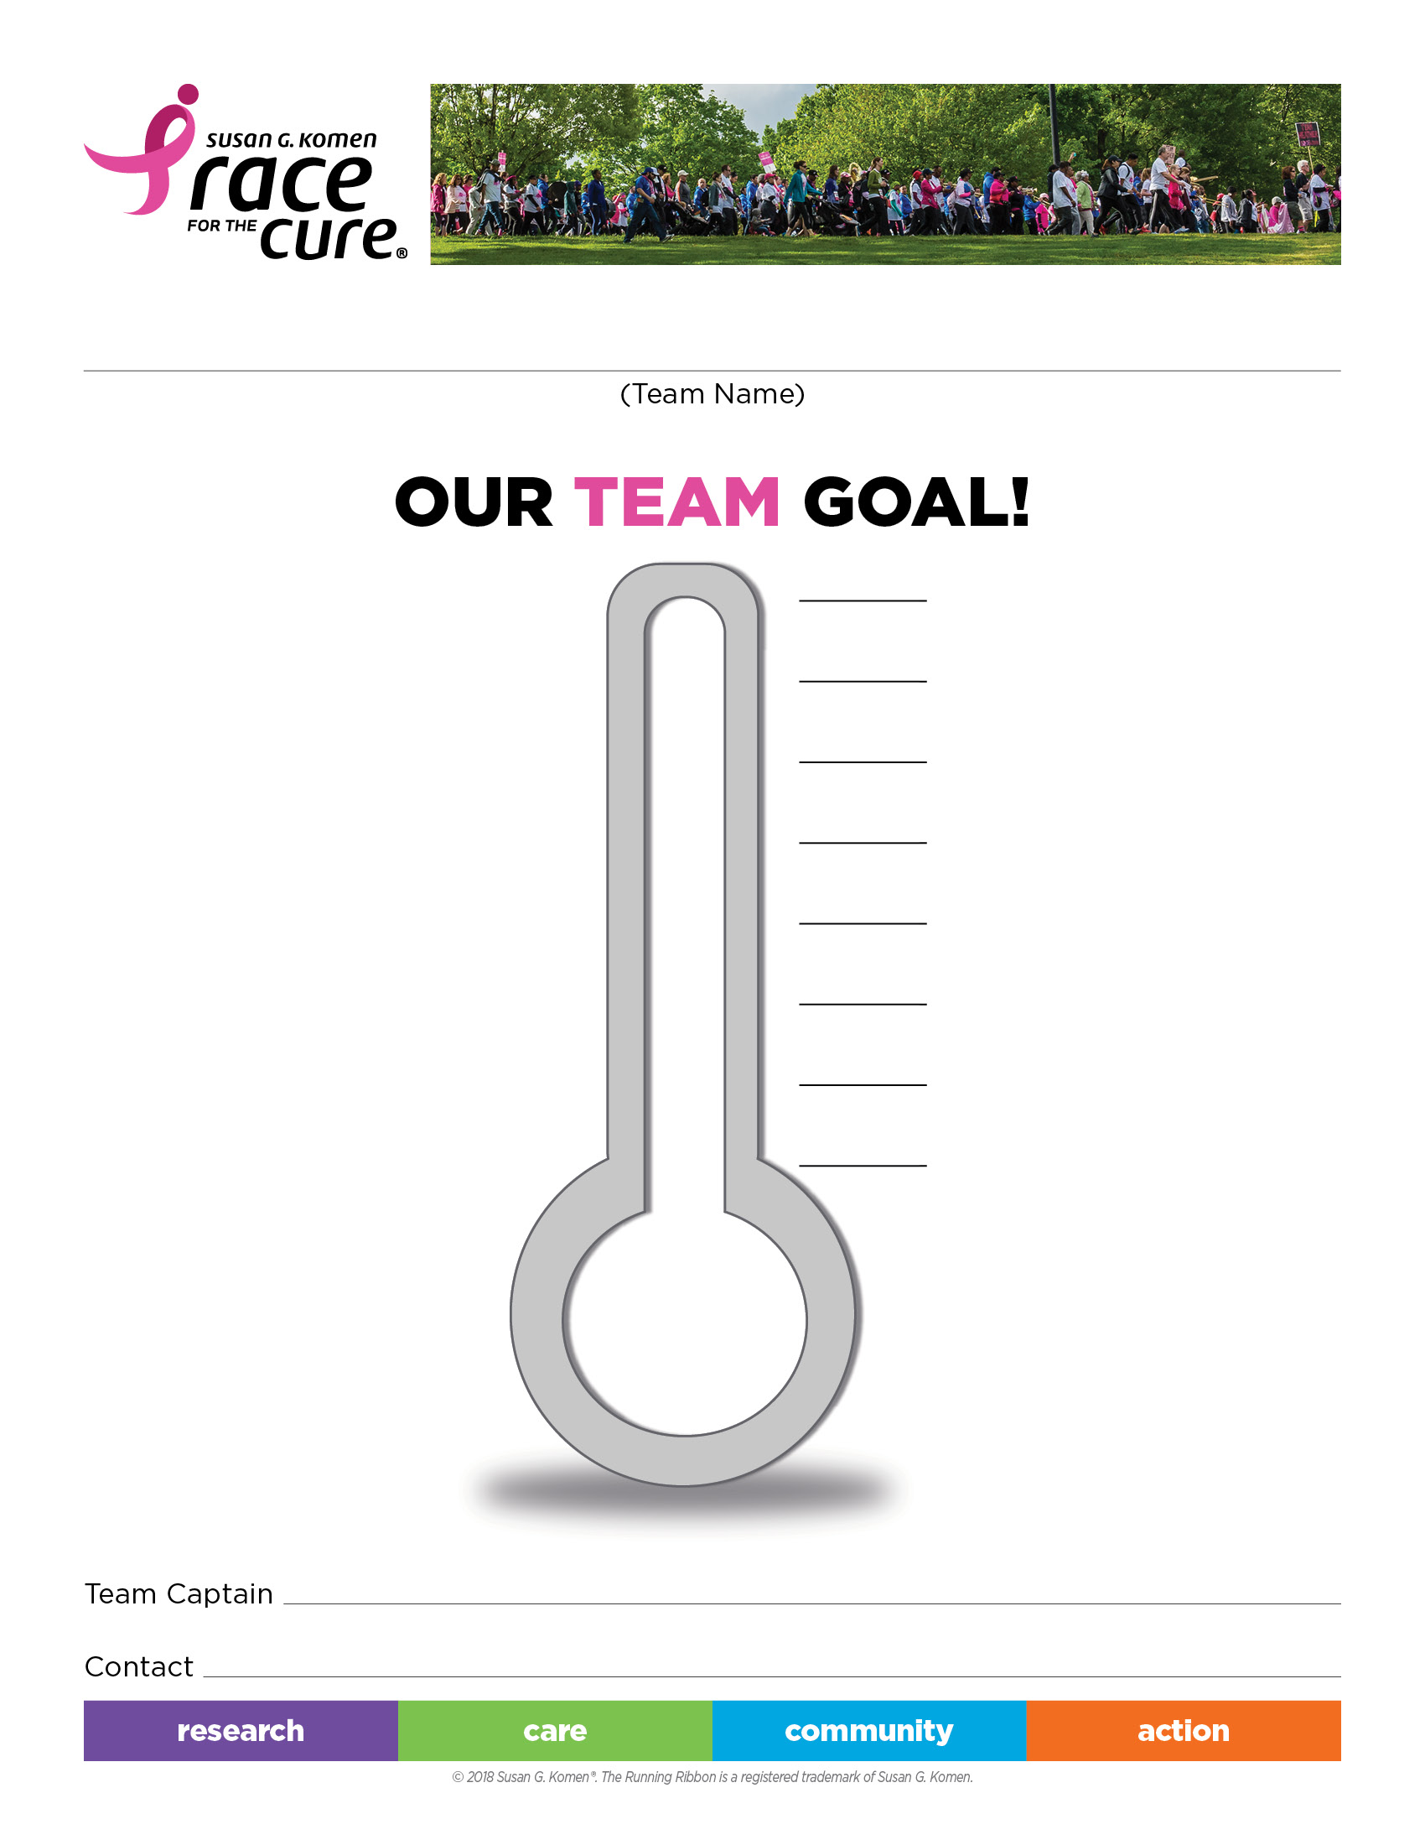

$

$

$

$

$

$

$

**Findlay Race**

**Saturday, Sept. 28, 2019**

Registration: 7:00-8:00 a.m.

Opening ceremony: 8:30 a.m.

Race Begins: 9:00 a.m.

$

Team Name: _______________________________________________

Team Goal: _______________________________________________

Team Captain: _______________________________________________