

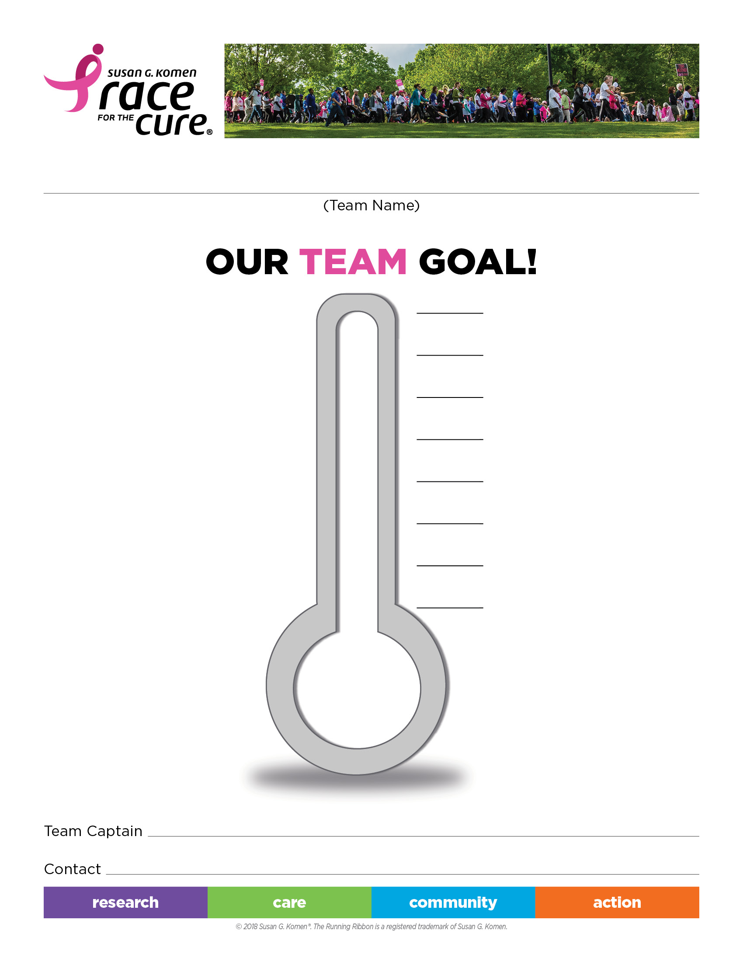

$

$

$

$

$

$

$

**Toledo Race**

**Sunday, Sept. 29, 2019**

Registration: 7:30-9:00 a.m.

Opening ceremony: 9:00 a.m.

Race Begins: 9:30 a.m.

$

Team Name: _______________________________________________

Team Goal: _______________________________________________

Team Captain: _______________________________________________